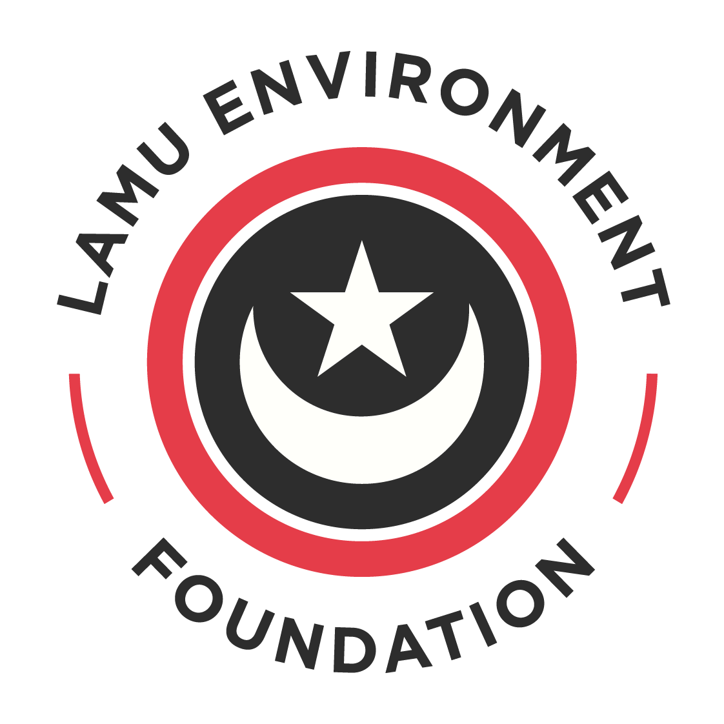

LAMU ENVIRONMENT FOUNDATION GRANT APPLICATION FORM WITH GUIDANCE

Please note all applications must be submitted through our online form, this document is only for support in drafting and completing your proposal. Some questions have been omitted to reduce repetition as they are simple questions organisational detail questions.
Before you complete an application, we encourage you to contact us via email, sharing a short concept note (max 500 words) with the amount you need for the work to express your interest in funding. We will come back to you and arrange a call for early feedback and to share our funding priorities with you.
Outcomes of the project and indicators measure the achievements of the project are outlined in the ‘CC Logic Model’. Please review this and to identify the most relevant outcomes and indicators for your project.

- ORGANISATION DETAILS

Questions A – D do not need to be completed on this form
- Organisation name
- Lead contact details
  - First name/Last name/Email/Phone/Role within the organisation
- Organisation address
- Year of establishment
- Legal status – you will need certificate of incorporation
Questions F – H do not need to be completed on this form
- Website
- Social media URLs
- Has your organisation applied for a grant with us before? Yes/No
- Tell us about your organisation’s relevant experience and why it is suited for this grant (Maximum 250 words)

- Please tell us about the key people who will deliver the project and their relevant qualifications and experience in running conservation projects e.g. project manager, technical expert, finance officer (Maximum 250 words)

- Please name any other organisations involved with this grant application and their roles in the project (Maximum 100 words)

- PROJECT OVERVIEW

  - Title

  - Project summary (Maximum 100 words)

  - Proposed start and end date of the project

  - Where will the project take place? (Maximum 50 words)

  - What environmental concern is your project is aiming to address? (Maximum 100 words)
Use this section to show that you understand the environmental issue that you’re addressing with your project. This will help the panel to see you fully udnerstand the challenges.

Questions 2.7 - 2.7 do not need to be completed on this form
  - Your project will be implemented through:
    - Direct environmental action (field work)
    - Awareness raising and/or education
    - Research and analysis
    - Engagement with communities
    - Campaigning
    - Advocacy and lobbying
    - Other – please specify
You selected 'Other' please specify: (Maximum 10 words)
  - Which natural habitat will your project be focusing on?
- Terrestrial
- Marine
- Wetland
- Freshwater
- Other
You selected 'Other' please specify: (Maximum 10 words)
- PROJECT IMPLEMENTATION

  - Please describe the project including the aims and objectives, methodologies and expected results. (Maximum 1000 words)

  - Please list and describe each of the project’s activities. In section 4, we will ask you to select from a list the outcomes of these activities and the indicators you will use to measure the achievements of your work.

ACTIVITY 1
(Name/description & expected results/expected completion date

ACTIVITY 2
(Name/description & expected results / expected completion date

ACTIVITY 3
…

You can add as many activities as you would like here
Question 3.3 does not need to be answered on this form
  - Which of the following groups are you planning to engage with during this project? You can select more than one
    - Local residents
    - Children and young people
    - Farmers
    - Fishermen
    - Land owners
    - Scientists
    - Protected area managers
    - Tourists
    - Tourism industry
    - Hospitality industry
    - NGOs
    - Local, regional or national government
    - Educational institutions
    - Media
    - Other
You selected 'Other' please specify: (Maximum 10 words)

    - PROJECT IMPACT
This section will be completed online using a multiple-choice mechanism so you do not need to complete these questions here.
4.1 In this section, we ask you to select up to three environmental outcomes of your project’s activities and up to three indicators for them to measure the achievements of your work. Please note that at the end of the project, you will be asked to report on these indicators.
- What are the environmental outcomes that the project aims to achieve? Please select a maximum of three. If you select ‘Other’ please specify.
- What indicators will you use to track the achievements at the end of the project? Please select a maximum of three. If you select ‘Other’ please specify.

4.2 In this section, we ask you to select up to three social, economic and policy outcomes of your project’s activities and up to three indicators for each of them to measure the achievements of your work. Please note that at the end of the project, you will be asked to report on these indicators.
- What are the social, economic and policy outcomes that the project aims to achieve? Please select a maximum of three. If you select ‘Other’ please specify.
- What indicators will you use to track your achievements at the end of the project? Please select a maximum of three. If you select ‘Other’ please specify.

    - RISKS
  - Describe any risks or uncertainties that might affect the project and how you will try to mitigate them (Maximum 250 words)
All projects come with risks – you will not be deducted marks for identifying these. Instead it will show the panel that you fully understand the challenges in implementing the project and that you have considered all eventualities.

  - Could the project lead to any unintended negative consequences? (Maximum 250 words)

  - Are there any factors that may affect the timeline of the project? (Maximum 250 words)

    - PROJECT LEGACY
If you plan to continue your work beyond the end of this funding, please tell us how (Maximum 100 words).

    - ADDITIONAL INFORMATION
  - Is there anything we could do besides funding to support you and/or this project? (Maximum 100 words)

  - If you have any documents or research supporting the project, please share with us here (Space to paste link plus UPLOAD BUTTON)
    - BUDGET
- Currency:
- Total project cost:
- Amount requested from us:
- Amount requested from other sources (if any):
You must complete a full budget template with your application the template is available in the link below.
- Full project budget: please download and complete this template then upload here

    - DECLARATION
Please confirm the following:
- I confirm that all the information in this application is correct and accurate to the best of my knowledge. I agree that you can check the information in it and any supporting documents with other people and organisations if required.
- My organisation has the power to accept a grant, under your terms, and the power to pay back the grant if the terms are not being met.
- I understand that any misleading statements (whether deliberate or accidental) I give at any point during the application process, or any information I knowingly withhold, could mean my organisation’s application is not valid, in which case you will cancel the grant and claim back the money we have received, stop assessing and return the application, or withdraw any grant you offered my organisation.
- I am authorised to put forward this application on behalf of my organisation.
- On behalf of my organisation, I agree that if we receive any grant from you for our project, we will keep to the standard terms of the grant and any further terms and conditions set out in the grant notification letter.

